1990 June

Use the following information to answer the next question.

- A laser pulse of frequency 5.0 x 10¹⁴ Hz is aimed at a mirror 8.0 x 10⁴ m away and the reflected pulse is detected when it returns. The time between transmission and detection of the pulse is measured to be 5.5 x 10⁻⁴ s. The calculated speed of light is
A. 1.1 x 10⁸ m/s
B. 1.6 x 10⁸ m/s
C. 2.9 x 10⁸ m/s
D. 3.0 x 10⁸ m/s

Use the following information to answer the next question.

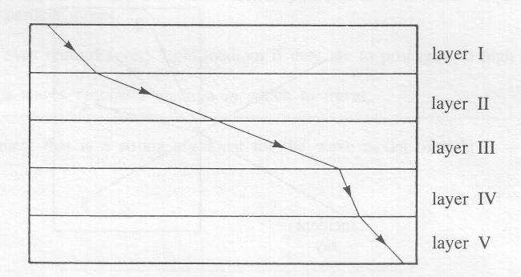

- If layer II contains air, which layer could be a vacuum?
A. I
B. III
C. IV
D. V

- Two waves of the same frequency with amplitudes of 4.3 cm and 7.8 cm travel at 330 m/s and are completely out of phase. The resultant amplitude of the combined wave is
A. 12.1 cm
B. 6.0 cm
C. 4.3 cm
D. 3.5 cm

Use the following information to answer the next question.

In the diagram below, a wave travelling from air to glass is represented by an incident ray.
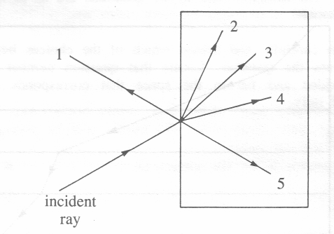

- The most likely distribution of the wave energy would be in the directions of arrows
A. 1 and 2
B. 1 and 4
C. 5 and 2
D. 5 and 3

- Monochromatic light of wavelength 6.20 x 10⁻⁷ m falls on a diffraction grating at normal incidence. A screen is placed at a distance of 3.50 m from the grating. If the fourth-order bright band appears at an angle of 30.0° from the incident ray, the grating spacing is
A. 2.02 x 10⁻⁵ m
B. 4.96 x 10⁻⁶ m
C. 1.24 x 10⁻⁶ m
D. 8.27 x 10⁻⁸ m

- Römer gathered data to measure the speed of light by observing
A. lantern flashes on distant hills
B. light directly radiated by the sun
C. the movement of Jupiter's moons
D. light reflected from an octagonal mirror

- The statement that is a strong argument for the wave model of light is
A. Interference and diffraction of light are more easily explained by a wave model.
B. Interaction of light with some atomic particles is more easily explained by a particle model.
C. Waves require a very rigid medium if they are to propagate at high speeds.
D. All waves require a medium in which to travel.

- When Iceland spar (calcite) produces two rays from one incident ray, the emergent rays
A. travel at different speeds in air
B. have different cross-sectional areas
C. are polarized in perpendicular planes
D. are longitudinal waves for one ray and transverse waves for the other

- If the Canadian flag is illuminated by a pure blue light, it will appear to be
A. red and blue
B. red and white
C. black and blue
D. black and white

- The prediction that light travels faster in water than in air is consistent with the
A. photon model of light
B. classical wave model of light
C. de Broglie wave model of light
D. classical particle model of light
Use the following information to answer the next question.

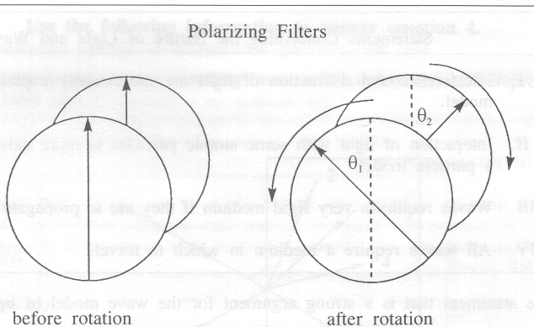

The arrows indicate the directions of the axes of polarization.

- Two polarizing filters are rotated in opposite directions. If the axes of the filters are initially aligned, to what pair of angles could the filters be rotated so that there will be minimum transmission of light through the filters?
A. θ₁ = 22.5° and θ₂ = 22.5°
B. θ₁ = 30° and θ₂ = 60°
C. θ₁ = 40° and θ₂ = 60°
D. θ₁ = 90° and θ₂ = 90°

- The electrostatic force between an electron and a helium (He²⁺) nucleus that are separated by a distance of 2.0 x 10⁻¹⁰ m is
A. 1.2 x 10⁻²⁷ N
B. 2.3 x 10⁻¹⁸ N
C. 1.2 x 10⁻⁸ N
D. 2.3 x 10²⁹ N

Use the following information to answer the next question.

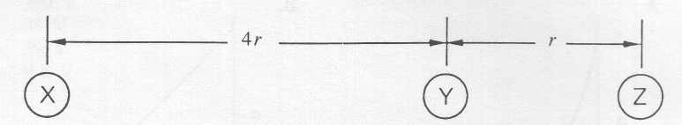
Three objects are each negatively charged.
- If there is no net force on Y, the relationship between the charges must be such that the charge on
A. X is 4 times greater than the charge on Z
B. X is 16 times greater than the charge on Z
C. Y is less than the charge on either X or Z
D. Y is greater than the charge on either X or Z

- Coulomb's Law of electrostatic force and Newton's Law of Universal Gravitation each state that force is
A. calculated using the same proportionality constant
B. inversely proportional to the distance of separation between the objects
C. directly proportional to the product of charges (or masses) of the objects
D. directly proportional to the square of the distance of separation between the objects

- A unit for electric field strength is
A. V
B. N/C
C. J/C
D. N/(C•m)

- Electric potential difference may be defined in terms of
A. force per unit current on a wire
B. force per unit charge on a small test charge
C. work done per unit charge in moving a test charge
D. momentum change per unit current of an electric current

- Two positively charged objects are held close together on a frictionless surface. If one of the objects is released, the acceleration of the released object can be represented by graph
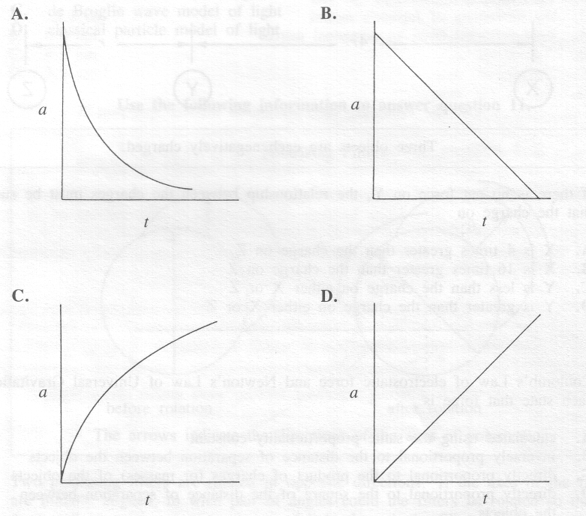

- What will be the speed of an electron that accelerates from rest through a potential difference of 5.0 x 10² V?
A. 9.4 x 10⁶ m/s
B. 1.3 x 10⁷ m/s
C. 1.8 x 10¹⁴ m/s
D. 3.3 x 10¹⁶ m/s

- Alternate layers of two different metals are components used in the construction of
A. a voltaic cell
B. an induction coil
C. a photoelectric cell
D. a television picture tube
- An electric crane lifts a 20.0 kg mass to a height of 10.0 m in 5.0 s. If the motor draws a current of 4.00 A and is 100% efficient, the minimum possible voltage applied to the motor must be
A. 390 V
B. 98 V
C. 39 V
D. 9.8 V

Use the following information to answer the next question.

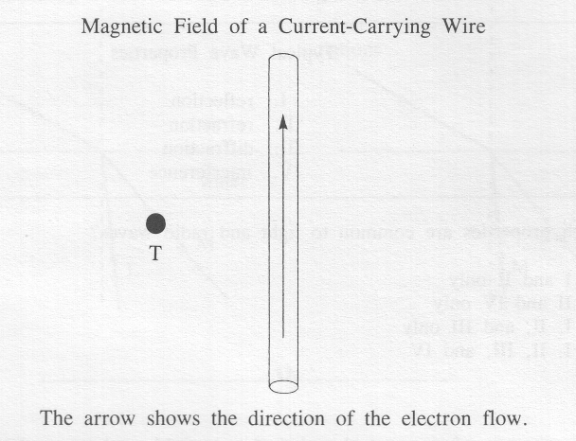

- The direction of the magnetic field at point T is
A. to the left
B. to the right
C. into the page
D. out of the page

- An electron moving at 2.5 x 10⁷ m/s perpendicularly through a magnetic field of 0.60 T experiences an acceleration of

A. 1.5 X 10¹¹ m/s²
B. 4.2 X 10¹³ m/s²
C. 2.4 x 10¹⁶ m/s²
D. 2.6 x 10¹⁸ m/s²

- An electron travels at 4.5 x 10⁵ m/s at right angles to a uniform magnetic field. A wire that is 5.0 x 10⁻² m long is perpendicular to the same field and experiences a magnetic force equal to the force on the electron. The current in the wire is
A. 1.4 x 10⁻¹² A
B. 1.1 x 10⁻⁷ A
C. 2.3 x 10⁴ A
D. 7.1 x 10¹¹ A

Use the following information to answer the next question.
Typical Wave Properties

I. reflection
II. refraction
III. diffraction
IV. interference

- Which properties are common to light and radio waves?
A. I and II only
B. II and IV only
C. I, II, and III only
D. I, II, III, and IV

- In the vacuum of space, a changing electric field produces a changing
A. parallel magnetic field
B. parallel electric current
C. perpendicular magnetic field
D. perpendicular electric current

- In an experiment similar to Hertz's, a student calculates that a spark jumps across the air gap and back again in 2.0 x 10⁻⁷ s. The wavelength of the electromagnetic wave transmitted by this coil is

A. 6.0 x 10¹ m
B. 6.0 x 10³ m
C. 1.5 x 10⁷ m
D. 1.5 x 10¹⁵ m

Use the following information to answer the next question.

A visible light beam (L) and a microwave (M) both travelling in air are incident upon water at the same angle. The index of refraction of water is 1.3 for visible light and 9.0 for microwaves.

- The diagram that best represents the paths the radiations would follow is
A. B.
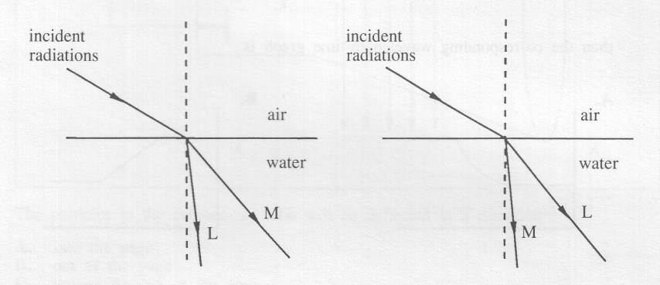

C. D.
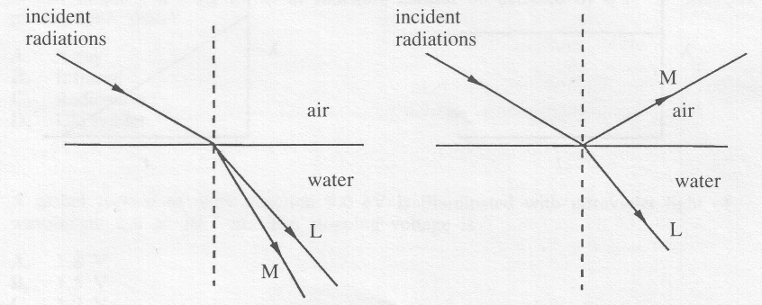

- If the frequency-time graph for a particular electromagnetic wave generator is
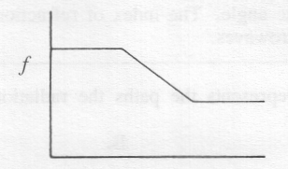

then the corresponding wavelength-time graph is

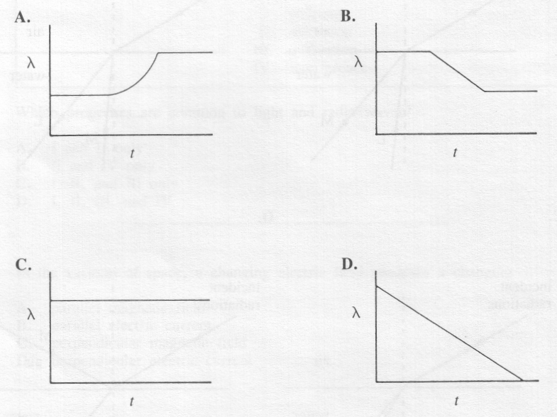

Use the following information to answer the next question.

A Cathode-Ray Tube in an External Magnetic Field

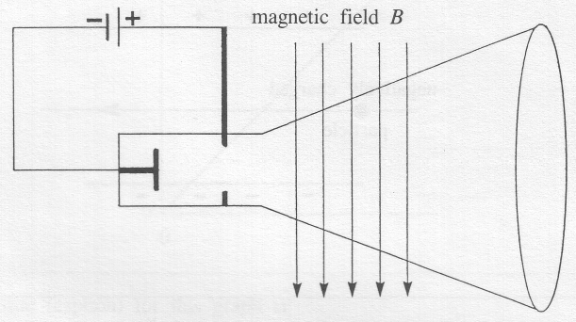

- The particles in the cathode-ray tube will be deflected in a direction
A. into the page
B. out of the page
C. toward the top of the page
D. toward the bottom of the page

- Which of the following forms of radiation cannot be detected by a photographic plate?
A. X-ray
B. Infrared
C. Radiowave
D. Ultraviolet

- A nickel surface of work function 5.0 eV is illuminated with ultraviolet light of wavelength 2.0 x 10⁻⁷ m. The stopping voltage is
A. 1.8 V
B. 1.5 V
C. 1.2 V
D. 0.88 V

Use the following information to answer the next question.

A Charged Particle Moving in Gravitational and Electric Fields

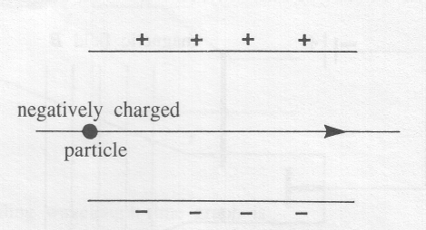

- A negatively charged particle of mass 3.0 x 10⁻¹⁴ kg moves horizontally through a vertical electric field of intensity 6.1 x 10⁴ N/C. The number of excess electrons on the particle is
A. 0.3
B. 1
C. 3
D. 30

- The relationship between the shortest wavelength λ_{min} produced by an X-ray tube and the accelerating voltage V is represented by
A. λ_{min} = hc/q_{e}V
B. λ_{min} = Vcq_{e}/h
C. λ_{min} = Vq_{e}/hc
D. λ_{min} = Vq_{e}c/h

- Alpha particles are scattered by gold foil. The evidence that most of the mass of the atom is concentrated in a small nucleus is that
A. all alpha particles experience slight deflection
B. some alpha particles are absorbed by the gold foil
C. some alpha particles are deflected through large angles
D. all alpha particles pass through the foil with no deflection

Use the following information to answer the next question.

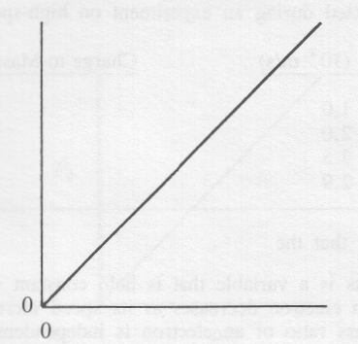

- A possible title (caption) for this graph is
A. photon speed as a function of frequency
B. photon energy as a function of frequency
C. photon energy as a function of wavelength
D. photon frequency as a function of wavelength

- When an electron makes a transition between the second and fourth energy levels in a hydrogen atom, the magnitude of the energy change of the atom is
A. 4.1 x 10⁻¹⁹ J
B. 2.7 x 10⁻¹⁹ J
C. 2.6 x 10⁻¹⁹ J
D. 1.6 x 10⁻¹⁹ J

- Classical wave theory cannot account for the
A. diffraction of X-rays
B. polarization of X-rays
C. refraction of microwaves in water
D. existence of a photoelectric threshold frequency

- The first experimental evidence that contradicted Newton's laws of motion was
A. Compton's evidence that X-rays act like particles
B. the discovery of absorption lines in the solar spectrum
C. the measurement of discrete energy levels in the hydrogen atom
D. that, for high kinetic energies, the measured speed of particles is always less than the speed of light

- To explain the Compton effect, it is necessary to
A. attribute momentum to the photon
B. attribute wavelength to the electron
C. deny conservation of energy for X-ray interactions
D. assume that fast electrons have a greater mass than slow electrons

- The speed of an electron that has the same momentum as a photon with a wavelength of 5.10 x 10⁻⁷ m is
A. 7.10 x 10² m/s
B. 1.01 x 10³ m/s
C. 1.43 x 10³ m/s
D. 2.98 x 10⁸ m/s

- The momentum of a photon that has an energy of 4.0 x 10⁻¹⁹ J is
A. 1.2 x 10⁻²⁷ kg•m/s
B. 1.3 x 10⁻²⁷ kg•m/s
C. 7.5 x 10⁻²⁷ kg•m/s
D. 8.8 x 10⁻²⁷ kg•m/s

- The de Broglie wavelength of a proton moving at 1.1 x 10⁷ m/s is
A. 2.5 x 10⁻²⁰ m
B. 3.6 x 10⁻¹⁴ m
C. 6.6 x 10⁻¹¹ m
D. 4.0 x 10⁻⁷ m
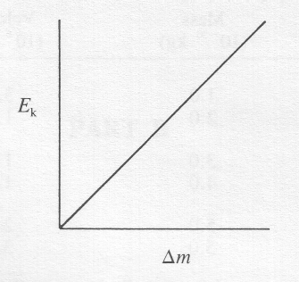
The graph shows the kinetic energy of an electron (E_{k}) as a function of its change in mass (Δm).

- The slope of the graph is equal to
A. h/c
B. h
C. c
D. c²

- A distinguishing characteristic of the Schrödinger equation is that it
A. is simpler than Bohr's model
B. provides a physical model of the atom
C. applies only to hydrogen and hydrogen-like atoms
D. has solutions that indicate probabilities rather than certainties

- In an experiment using an electron microscope to locate objects moving at a speed of 2.0 x 10³ m/s, there will be the least percentage error in determining the position of
A. a proton
B. a neutron
C. a molecule
D. an electron

- An electron moves with a velocity of 3.0 x 10⁶ m/s. This velocity can be measured to an accuracy of 10%. The greatest accuracy to which we could, in principle, measure the position of the electron is of the order of
A. 10⁻¹⁰ m
B. 10⁻¹² m
C. 10⁻²⁴ m
D. 10⁻³⁷ m

